

**Introduction**

What is GIT and why is it used?

Git is a version control system that is widely used in the programming world. It is used for tracking changes in the source code during software development. It was developed in 2005 by Linus Torvalds, the creator of the Linux operating system kernel.

Git is a speedy and efficient distributed [VCS t](https://www.w3docs.com/learn-git/version-control-software.html)ool that can handle projects of any size, from small to very large ones. Git provides cheap local branching, convenient staging areas, and multiple workflows. It is free, open-source software that lowers the cost because developers can use Git without paying money. It provides support for non-linear development. Git enables multiple developers or teams to work separately without having an impact on the work of others.

Git is an example of a distributed version control system (DVCS) (hence Distributed Version Control System).

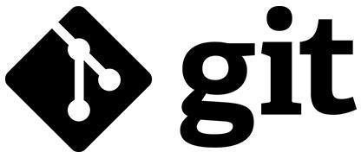

What is GITHUB?

It is the world’s largest open-source software developer community platform where the users upload their projects using the software Git.



What is the difference between GIT and GITHUB?

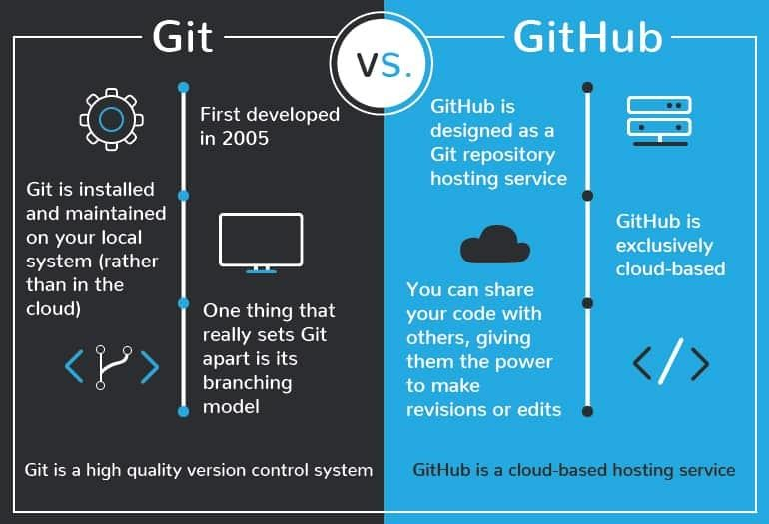

**What is Repository?**

A repository is a directory or storage space where your projects can live. Sometimes GitHub users shorten this to “repo.” It can be local to a folder on your computer, or it can be a storage space on GitHub or another online host. You can keep code files, text files, image files, you name it, inside a repository.

What is Version Control System (VCS)?

A version control system is a tool that helps you manage “versions” of your code or changes to your code while working with a team over remote distances. Version control keeps track of every modification in a special kind of database that is accessible to the version control software. Version control software (VCS) helps you revert back to an older version just in case a bug or issue is introduced to the system or fixing a mistake without disrupting the work of other team members.

Types of VCS

1. Local Version Control System
2. Centralized Version Control System
3. Distributed Version Control System

I. **Local Version Control System:** Local Version Control System is located in your local machine. If the local machine crashes, it would not be possible to retrieve the files, and all the information will be lost. If anything happens to a single version, all the versions made after that will be lost.

AI. **Centralized Version Control System:** In the Centralized Version Control Systems, there will be a single central server that contains all the files related to the project, and many collaborators checkout files from this single server (you will only have a working copy). The problem with the Centralized



Version Control Systems is if the central server crashes, almost everything related to the project will be lost.

BI. **Distributed Version Control System:** In a distributed version control system, there will be one or more servers and many collaborators similar to the centralized system. But the difference is, not only do they check out the latest version, but each collaborator will have an exact copy of the main repository on their local machines. Each user has their own repository and a working copy. This is very useful because even if the server crashes we would not lose everything as several copies are residing in several other computers.



## **Problem Statement**

“Build a website and deploy it on GitHub”

Many a times, while travelling we get into certain unforeseen situations where we run out of fuel or our vehicle gets overheated. On a deserted road, the possibility of finding a petrol pump nearby or a mechanic is negligible. In a situation like this we would need someone to provide assistance to help us get out of that situation. Here comes "ServeU” addressing the real time vehicle breakdown problems of customers in day-to-day life.



## **Solution**

Vehicle Servicing, Vehicle repairs and Car cleaning - we are your onestop solution for all things cars. ServeU intends to be the best roadside assistance provider in India by addressing the real time vehicle breakdown problems of customers in day-to-day life. A brainchild of 5 friends - Aadarsh Kumar, Aakash Jha, Aastha Anand, Aayushi Jain and Abhimanyu Nain, ServeU is a network of technology-enabled automobile service centres, offering a seamless car and bike service experience at the convenience of a tap. With our highly skilled technicians, manufacturer recommended procedures and the promise of genuine spare parts we are your best bet. Stay in the comforts of your home or office and make the most of our complimentary pick-up and drop-in service. Count on us to be your personal vehicle care expert, advisor and mechanic.

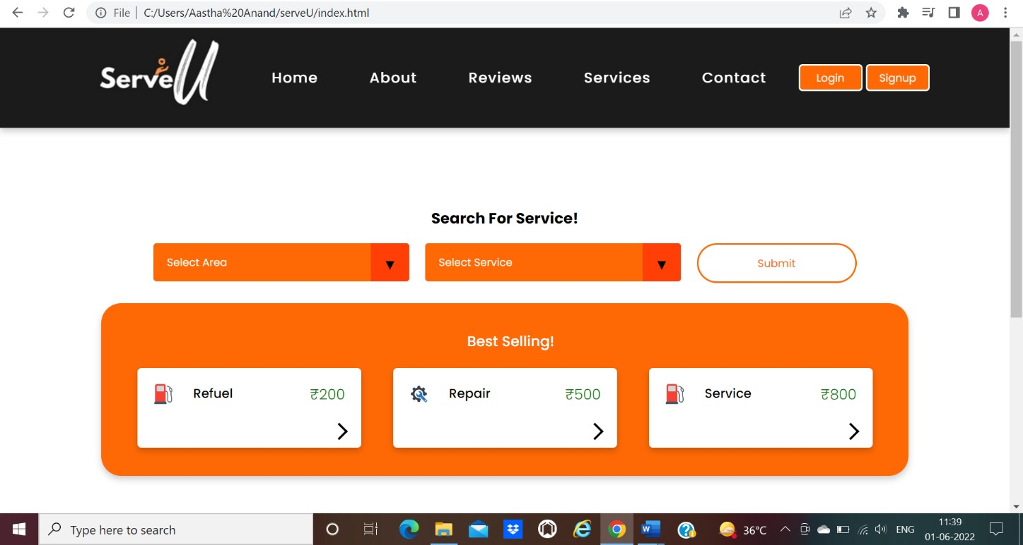

**Objective:**

The objective of this project is to associate programming with git because:

1. This is required because the collaboration makes the team work easy.
2. The code becomes manageable and we can build a clean repository.
3. Tracking and resolving of the errors is quite feasible in this process.
4. Moreover, we can make our locally available projects, globally available.





**Experiment**

**No.**

**01**

Aim: Create a distributed Repository and add members in project team

* + 1. Login to your GitHub account and you will land on the homepage as shown below. Click on Repositories option in the menu bar.

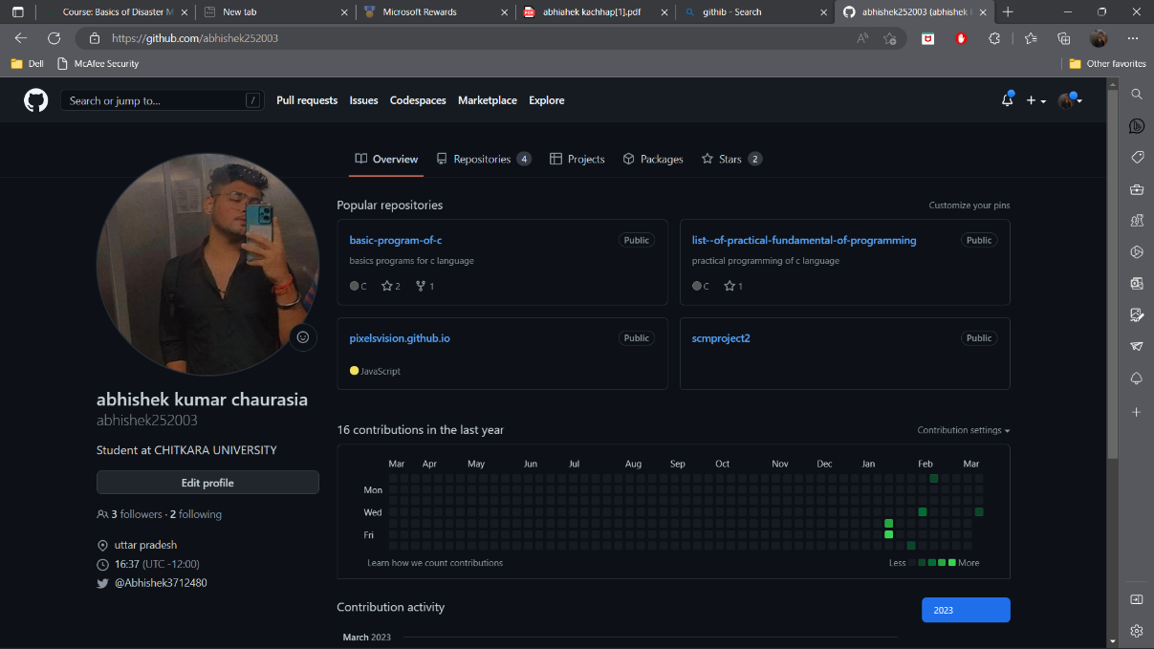

* + 1. Click on the ‘New’ button in the top right corner.

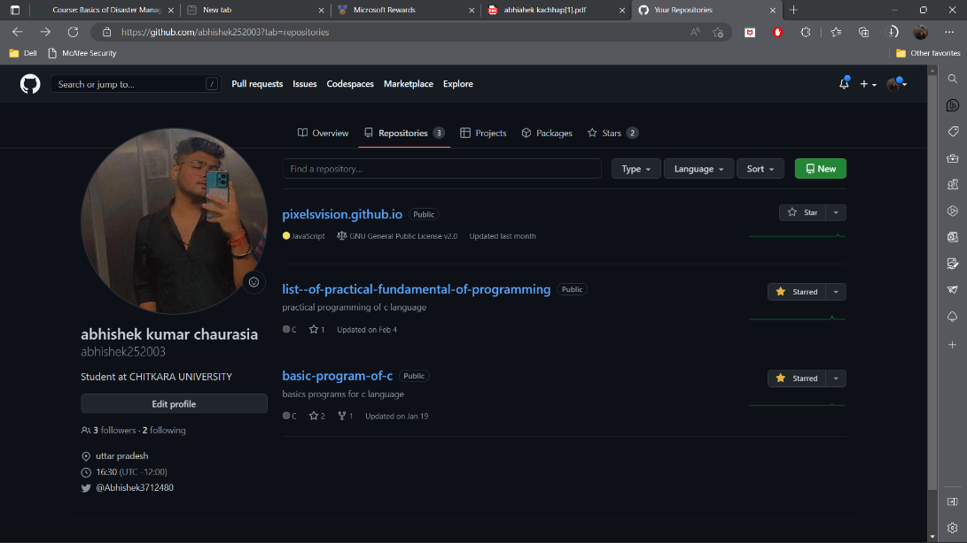

* + 1. Enter the Repository name and add the description of the repository.



* + 1. Select if you want the repository to be public or private.

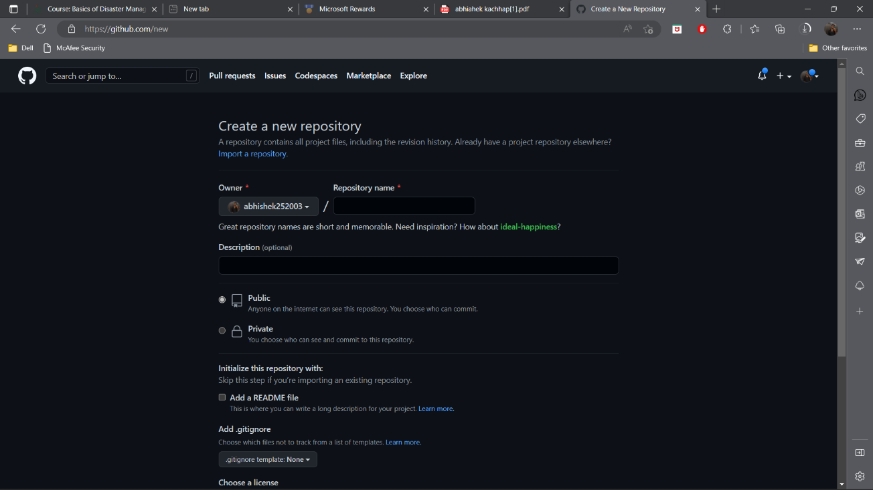

*(Repository created by repository owner: team member- Abhishek Chaurasia)*

* + 1. If you want to import code from an existing repository select the import code option.

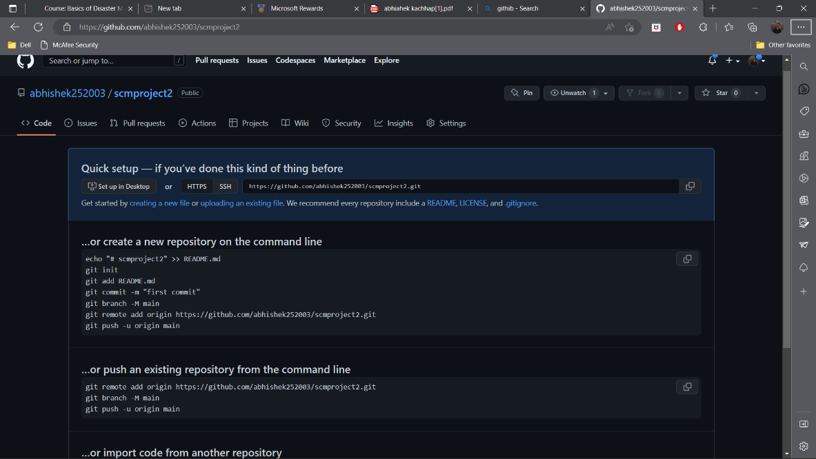

* + 1. Now, you have created your repository successfully.
    2. To add members to your repository open your repository and select settings option in the navigation bar.

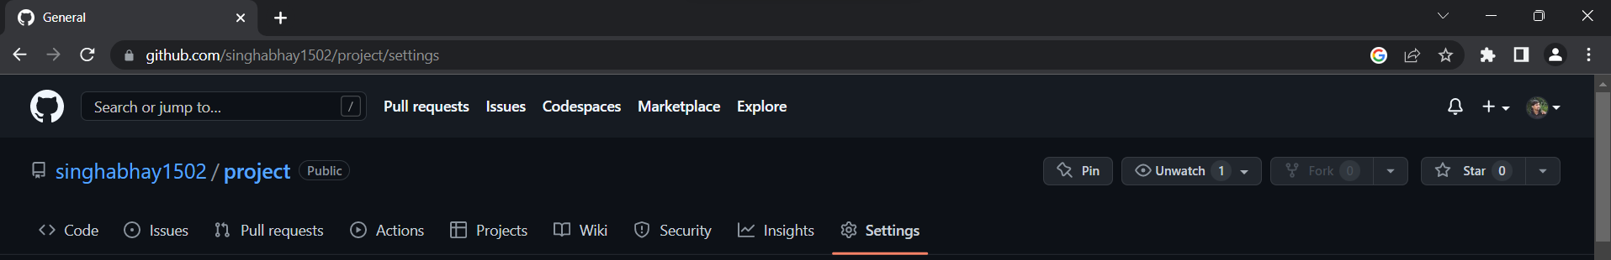

* + 1. Click on Collaborators option under the access tab.

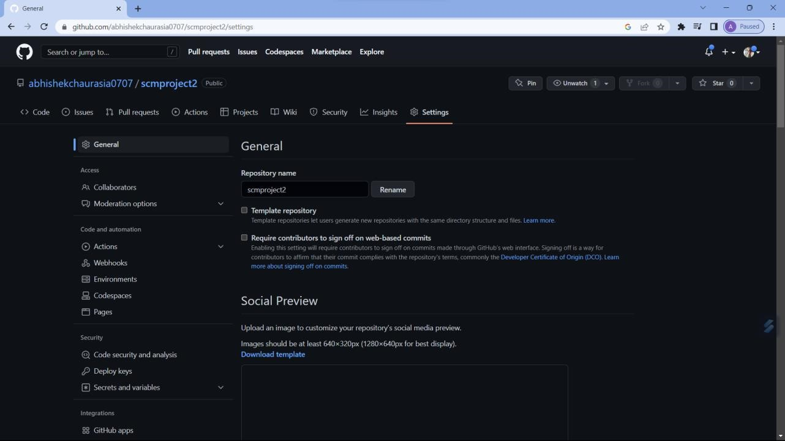

* + 1. After clicking on collaborators GitHub asks you to enter your password to confirm the access to the repository.

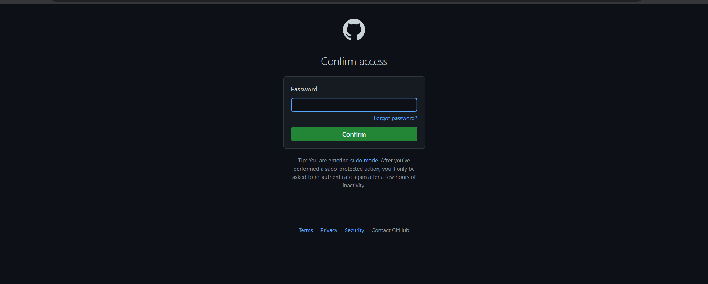

* + 1. After entering the password you can manage access and add/remove team members to your project.
    2. To add members click on the add people option and search the id of your respective team member.

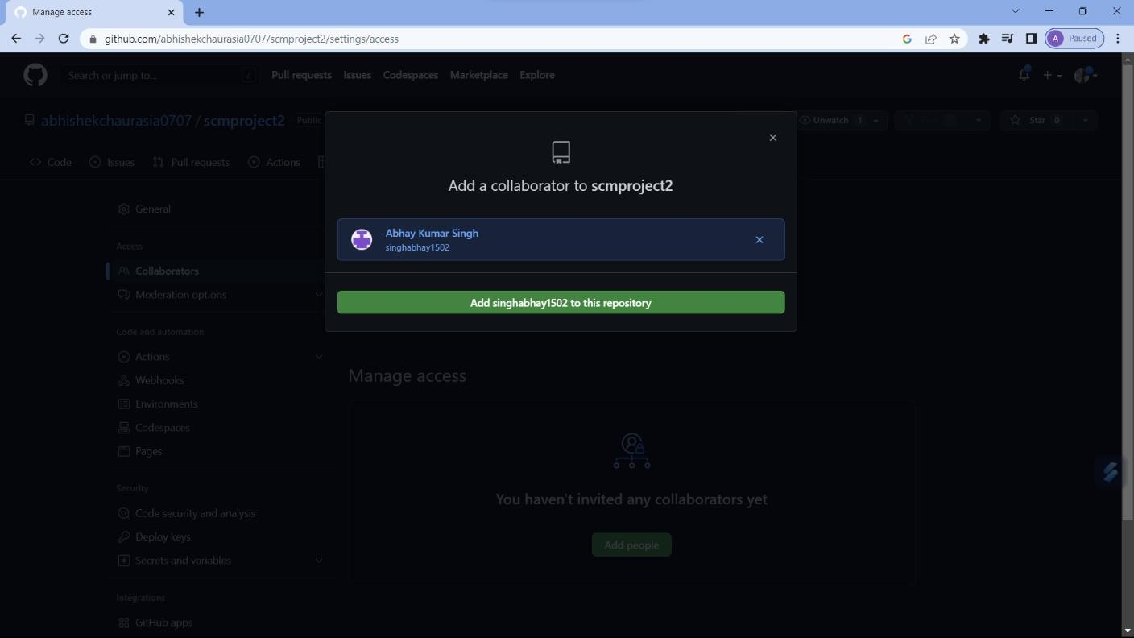

*(Collaborators added by repository owner: team member- Aakash)*

* + 1. To remove any member click on remove option available in the last column of member’s respective row.

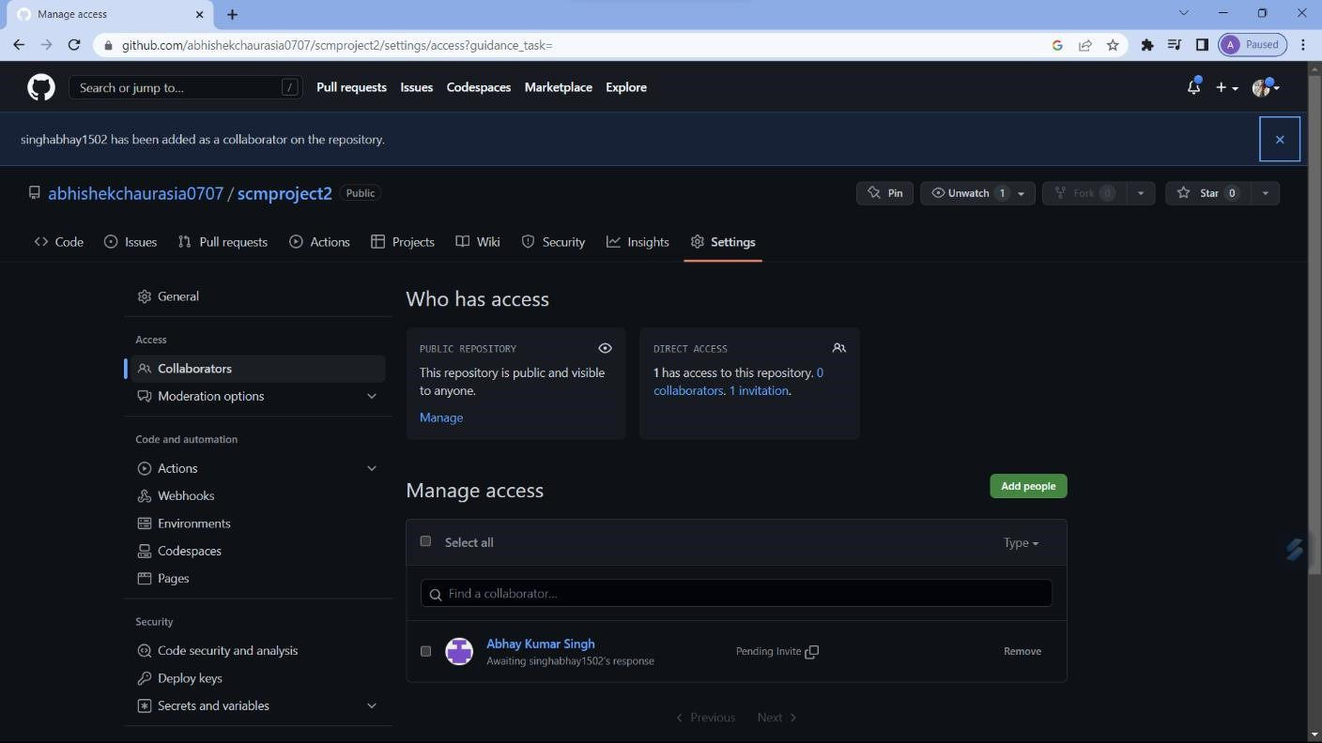

* + 1. To accept the invitation from your team member, open your mail registered with GitHub.

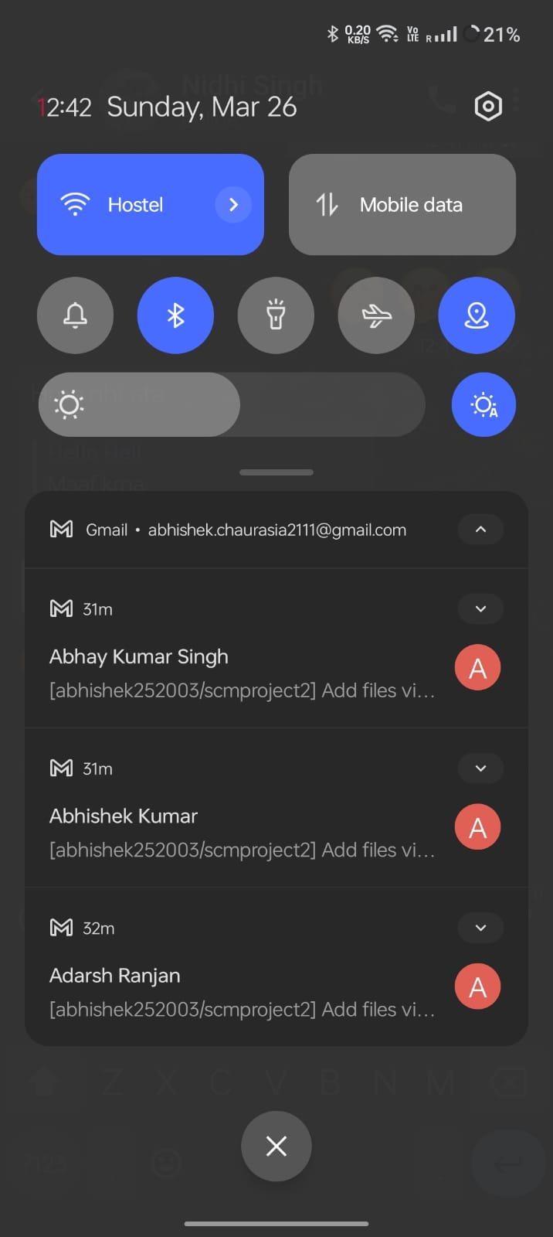

* + 1. You will receive an invitation mail from the repository owner. Open the email and click on accept invitation.

* + 1. You will be redirected to GitHub where you can either select to accept or decline the invitation.
    2. You will be shown the option that you are now allowed to push.
    3. Now all members are ready to contribute to the project.

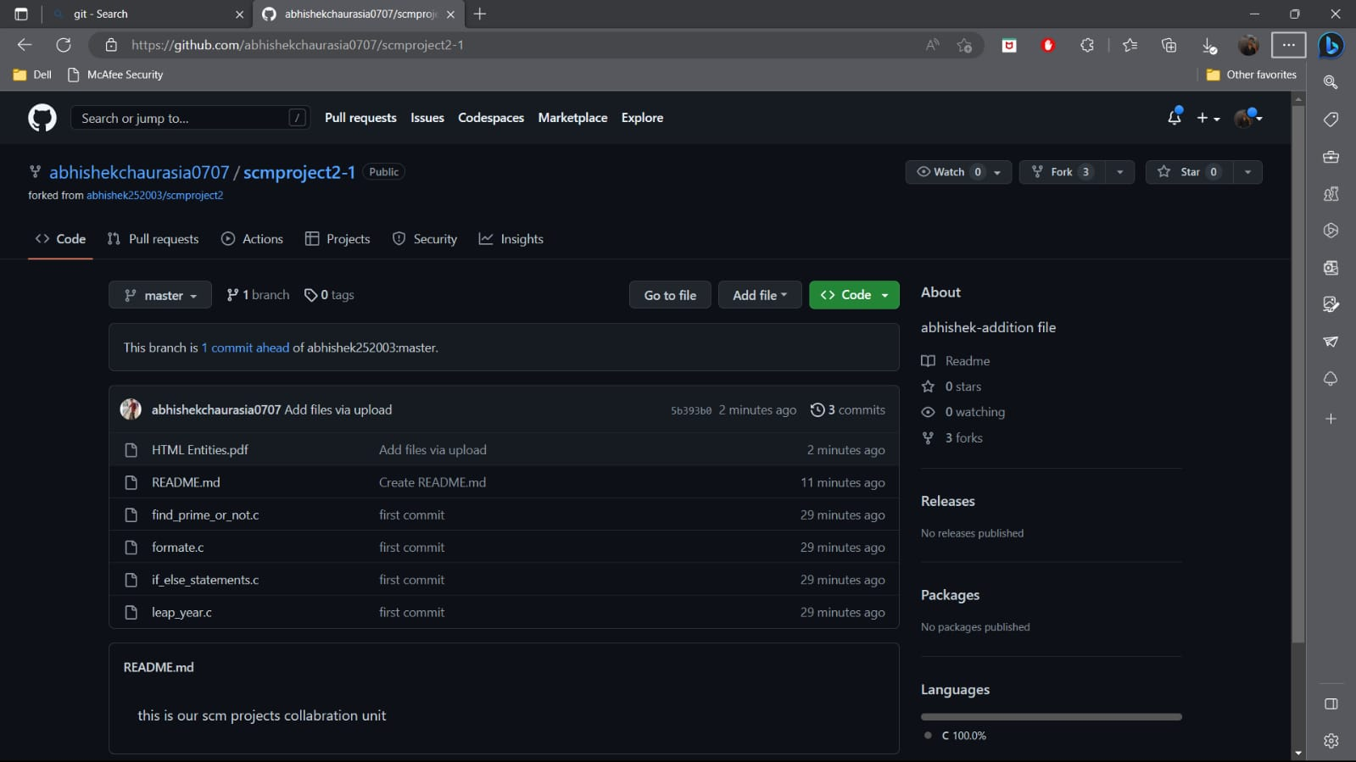





**Experiment**

**No.**

**02**

Aim: Open and Close a Pull Request

* 1. To open a pull request we first have to make a new branch, by using git branch *branchname* option.

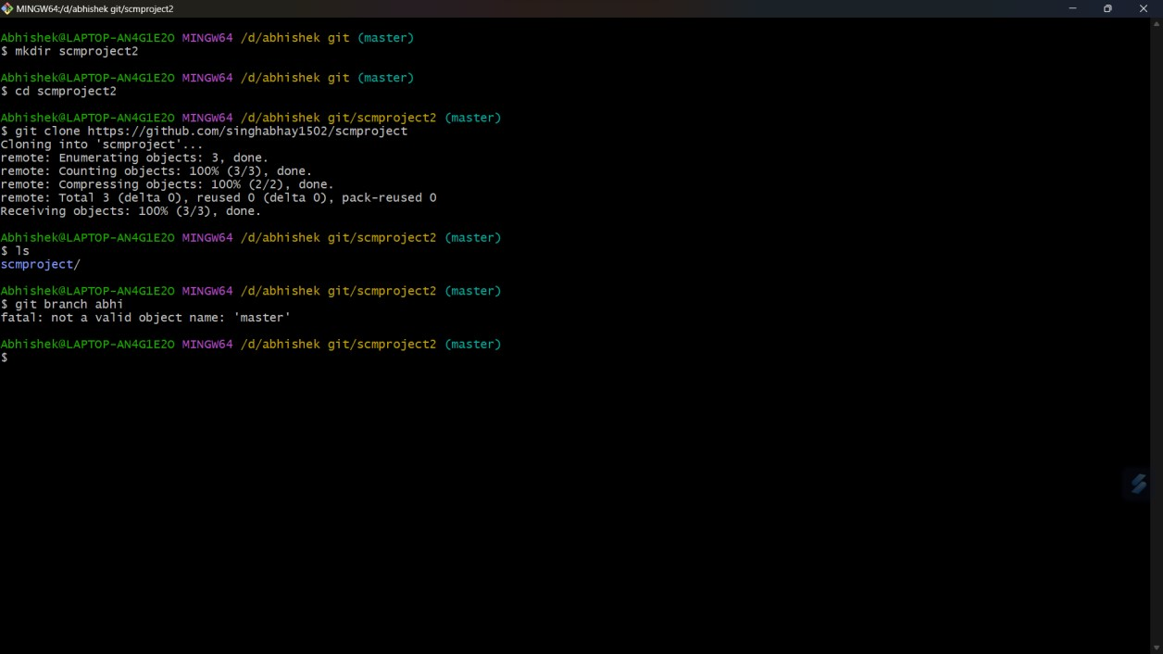

* 1. After making new branch we add a file to the branch or make changes in the existing file.

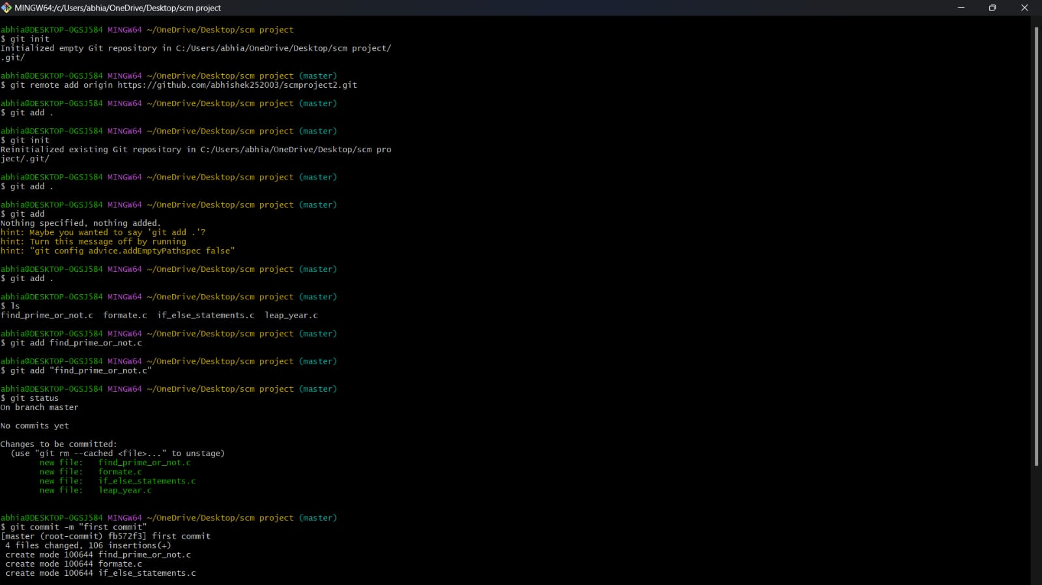

* 1. Add and commit the changes to the local repository.

* 1. Use git push origin *branchname* option to push the new branch to the main repository.

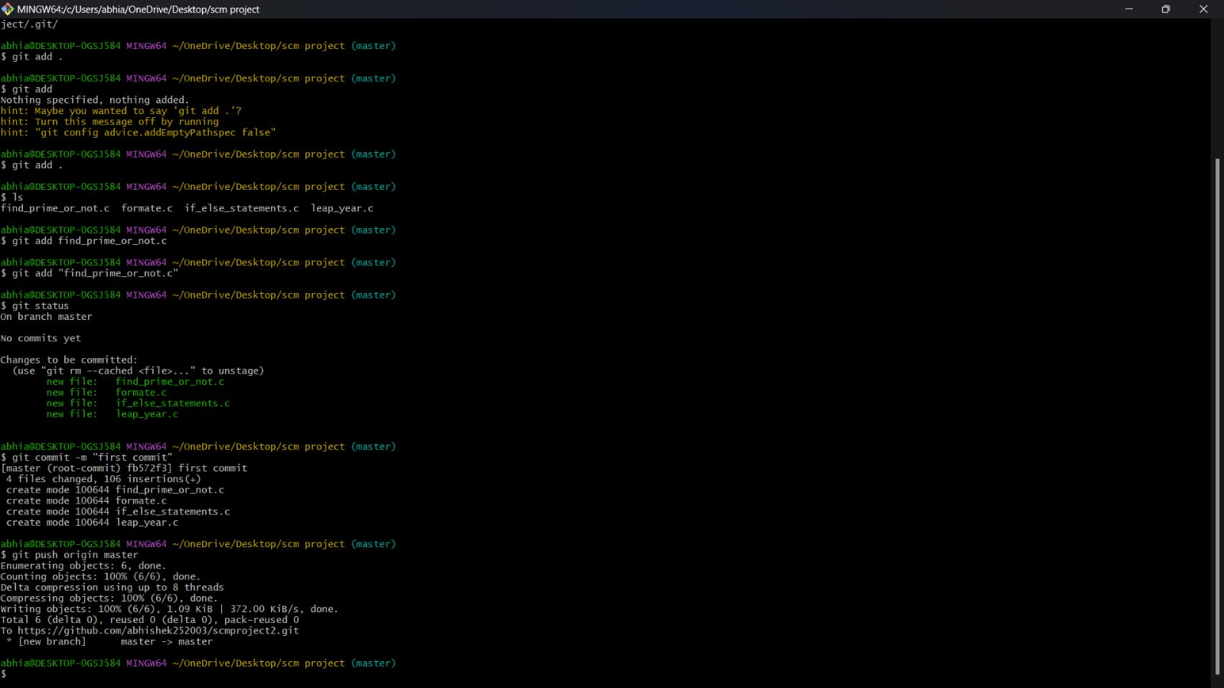

* 1. After pushing new branch GitHub will either automatically ask you to create a pull request or you can create your own pull request.

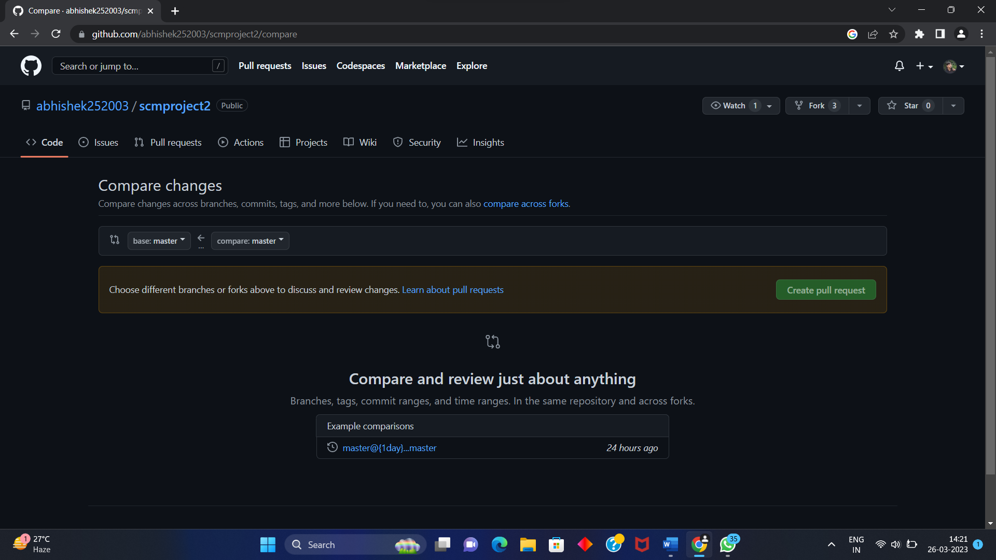

* 1. To create your own pull request, click on pull request option.

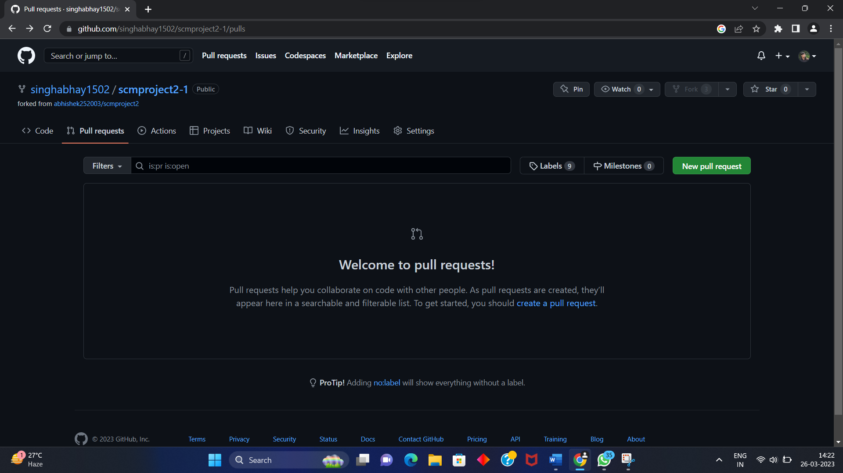

* 1. GitHub will detect any conflicts and ask you to enter a description of your pull request.

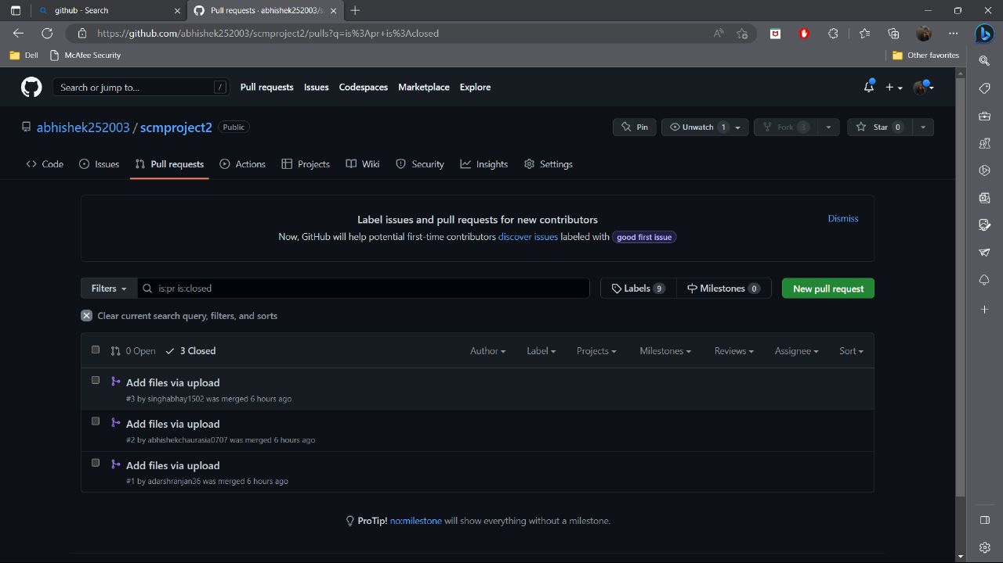

* 1. After opening a pull request all the team members will be sent the request if they want to merge or close the request.

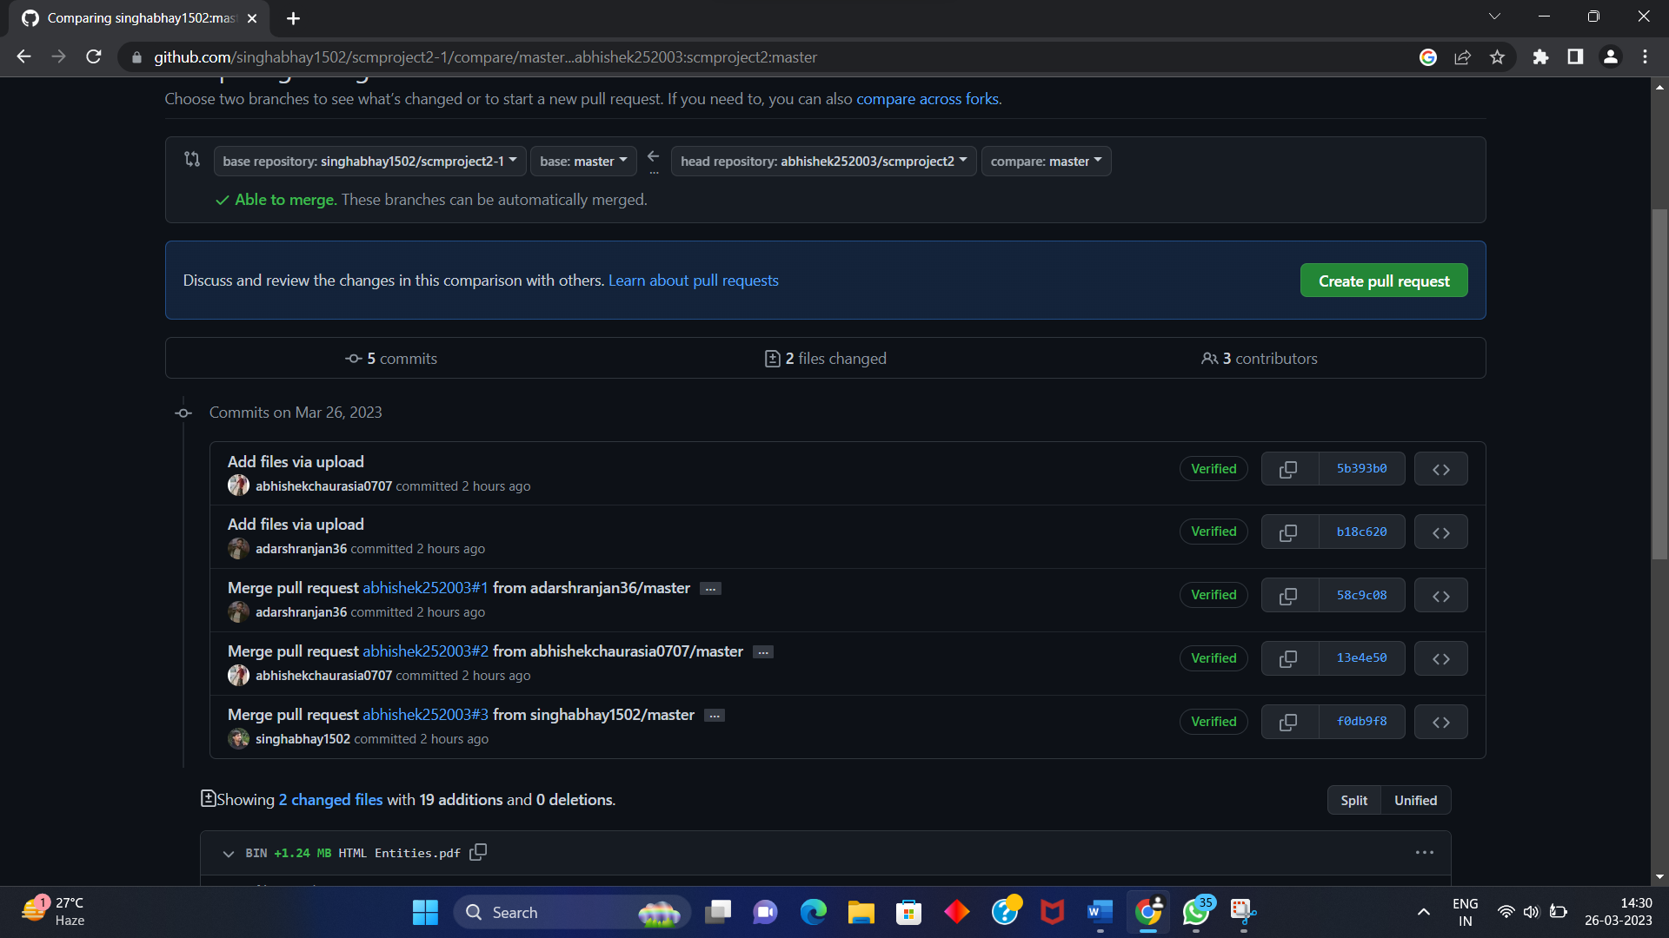

* 1. If the team member chooses not to merge your pull request they will close your pull request.

* 1. To close the pull request simply click on close pull request and add comment/ reason why you closed the pull request.

* 1. You can see all the pull request generated and how they were dealt with by clicking on pull request option.

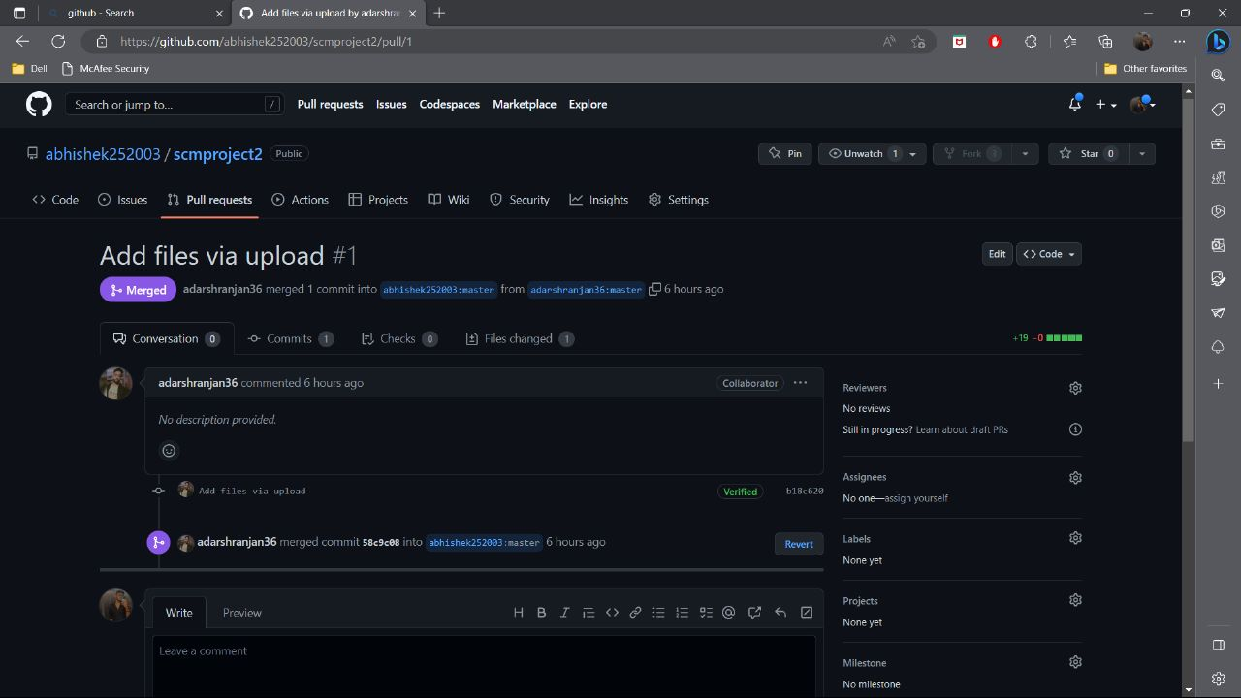



**Experiment**

**No.**

**03**

Aim: Create a pull request on a team member’s repo and close pull requests generated by team members on own Repo as a maintainer

To create a pull request on a team member’s repository and close requests by any other team members as a maintainer follow the procedure given below:

* 1. Do the required changes in the repository, add and commit these changes in the local repository in a new branch.



* 1. Push the modified branch using git push origin *branchname*.



* 1. Open a pull request by following the procedure from the above experiment.



* 1. The pull request will be created and will be visible to all the team members.

1. Ask your team member to login to his/her Github account.
2. They will notice a new notification in the pull request menu.



1. Click on it. The pull request generated by you will be visible to them.



1. Click on the pull request. Two options will be available, either to close the pull request or Merge the request with the main branch.
2. By selecting the merge branch option the main branch will get updated for all the team members.

1. By selecting close the pull request the pull request is not accepted and not merged with main branch.

1. The process is similar to closing and merging the pull request by you. It simply includes an external party to execute.

1. Thus, we conclude opening and closing of pull request. We also conclude merging of the pull request to the main branch.







**Experiment**

**No. 04**

Aim: Publish and print network graphs

The network graph is one of the useful features for developers on GitHub. It is used to display the branch history of the entire repository network, including branches of the root repository and branches of forks that contain commits unique to the network.

A repository's graphs give you information on traffic, projects that depend on the repository, contributors and commits to the repository, and a repository's forks and network. If you maintain a repository, you can use this data to get a better understanding of who's using your repository and why they're using it.

Some repository graphs are available only in public repositories with GitHub Free:

* Pulse
* Contributors
* Traffic
* Commits
* Code frequency
* Network

Steps to access network graphs of respective repository

1. On GitHub.com, navigate to the main page of the repository.
2. Under your repository name, click **Insights**.

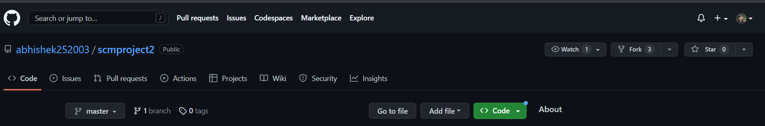

1. At the left sidebar, click on **Network**.

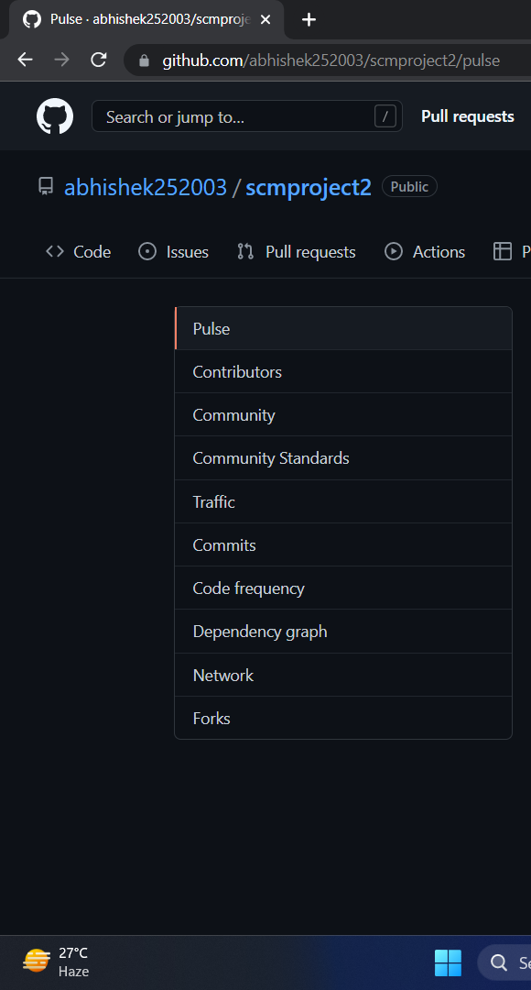

1. You will get the network graph of your repository which displays the branch history of the entire repository network, including branches of the root repository and branches of forks that contain commits unique to the network.

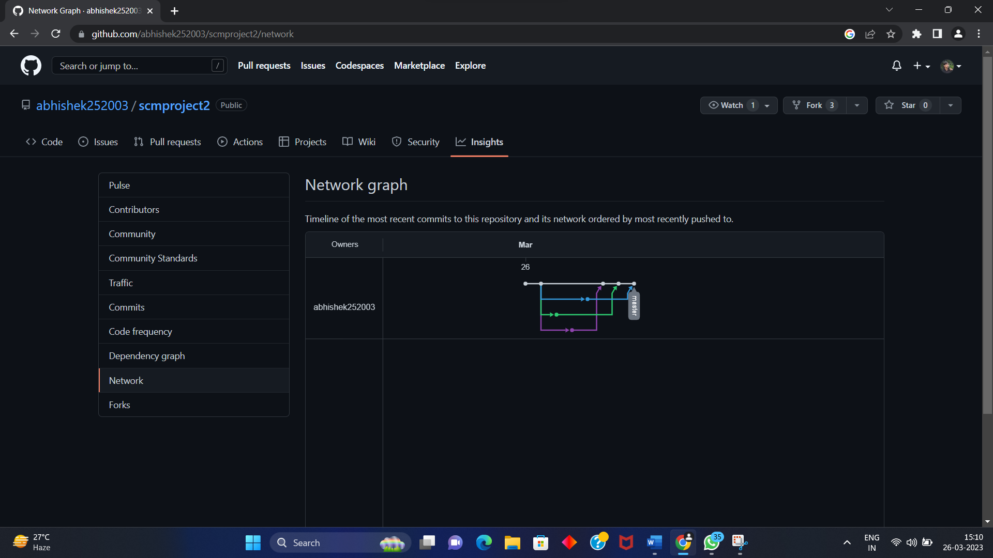

**Listing the forks of a repository**

Forks are listed alphabetically by the username of the person who forked the repository

Clicking the number of forks shows you the full network. From there you can click "members" to see who forked the repo.

1. On GitHub.com, navigate to the main page of the repository.
2. Under your repository name, click **Insights**.

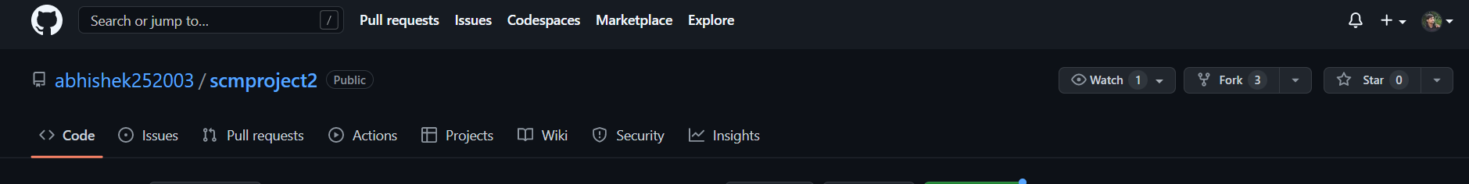

1. In the left sidebar, click **Forks.**

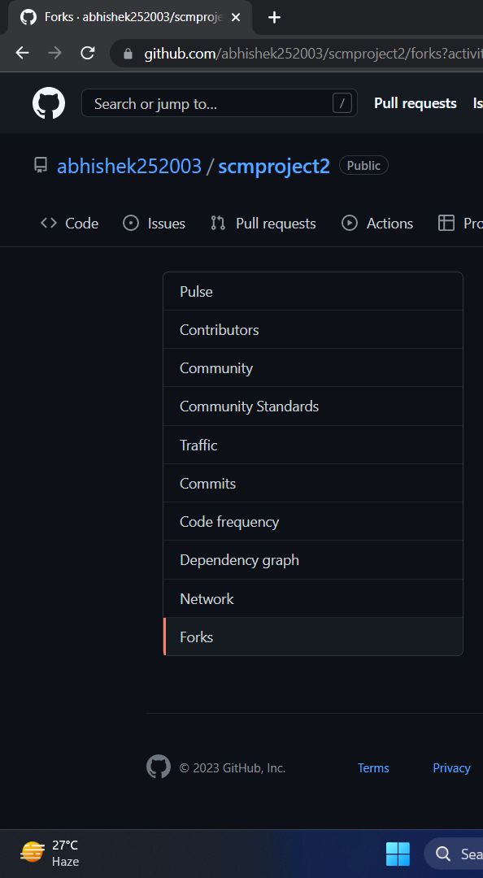

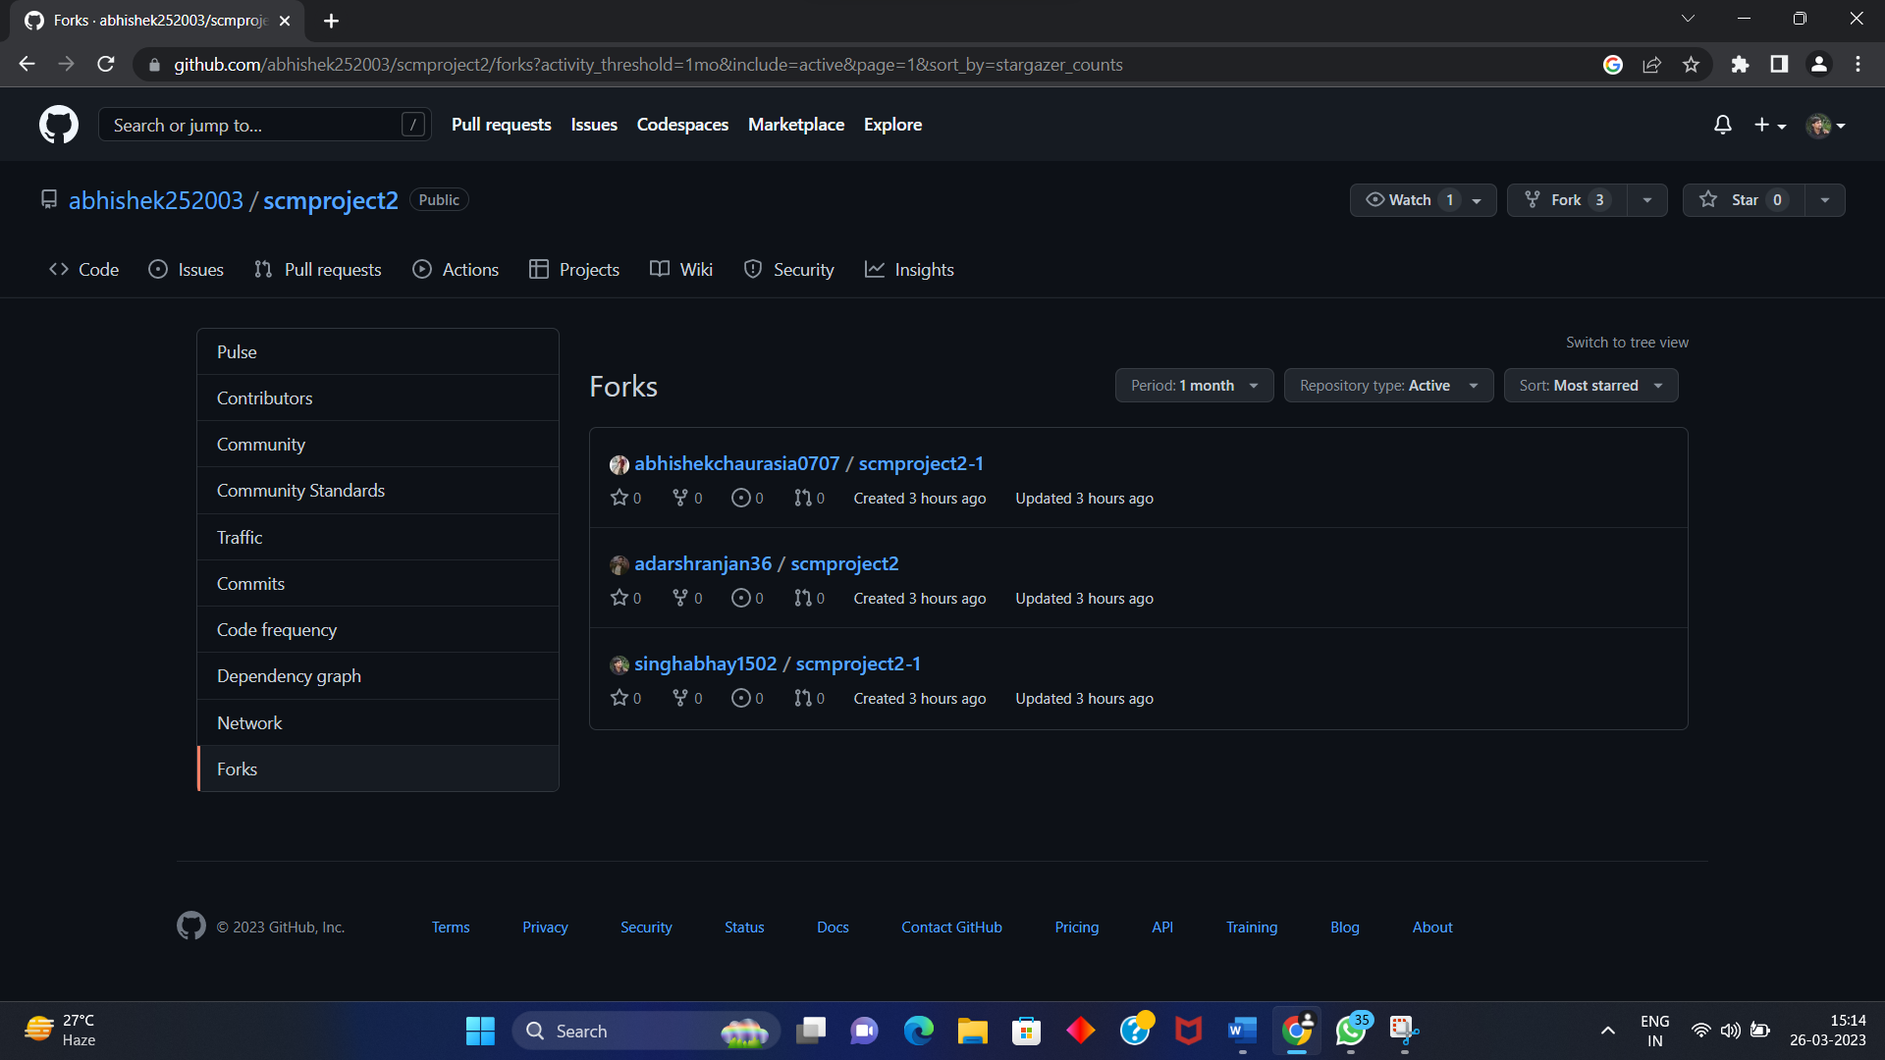

**Viewing the dependencies of a repository**

You can use the dependency graph to explore the code your repository depends on.

Almost all software relies on code developed and maintained by other developers, often known as a supply chain. For example, utilities, libraries, and frameworks. These dependencies are an integral part of your code and any bugs or vulnerabilities in them may affect your code. It's important to review and maintain these dependencies.

